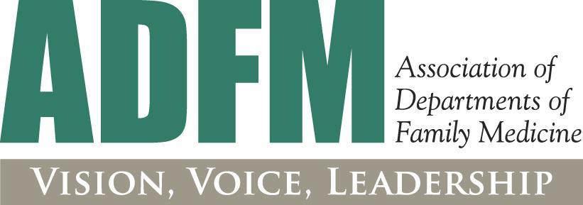

**Association of Departments of Family Medicine**

**2025 Annual Conference**

**February 18-21, 2025| Nashville, TN**

To nominate an individual to attend the ADFM conference as a Senior Leader, please complete this registration form and send it to Kim Sevedge at [adfm@adfm.org](mailto:adfm@adfm.org) with a note of approval from the member chair or administrator for the individual to attend (formal letter not required; an email indicating support is fine!).

**Name:** _____________________________________________________________________________________

**Institution:** _____________________________________________________________________________________

**Mailing Address:** ___________________________________________________________________________________________

**City:** _____________________________________________ **State:** _____________ **Zip:**________________

**Please enter the Voting Zip Code where you are registered to vote so that we can target our messaging and requests related to legislative action and other advocacy efforts.**

**___________________________________________________________________________________________**

**Telephone (daytime):** _______________________________ **Fax:** ________________________________

**Email:** _______________________________________________________________________

**Rolein Your Department:** ____________________________

**Is this your first ADFM meeting?**  (check) YES ____ NO ____

**Do you need any special accommodation to participate in the meeting?** YES ____ NO ____

*\*if yes, a staff member will reach out to you*

**Any dietary restrictions?**

* Vegetarian
* Vegan
* Gluten Free
* Other

REGISTRATION FEE*: If Member Dues are Already Paid If Renewing Dues with Registration

CHAIR $650 $2,158

SENIOR LEADER $650 N/A

ASSOCIATE $650 $1,268

ASSOCIATE (RETIRED/NOT EMPLOYED) $650 $958

ADMINISTRATOR $600 $934

ASSOCIATE ADMINISTRATOR $600 $908

ADMINISTRATOR SENIOR LEADER $650 N/A

**PRECONFERENCES AND OPTIONAL SESSIONS: (Additional fees apply)**

* 2/21; 8:00 am-5:00 pm **Administrators’ Preconference** Developing ourselves, our teams, and our departments ($165)   
  *Administrators only*
* 2/21; 1:00-5:00 pm **Leadership Development** Bridges and Pathways: Navigating Relationships and Career Transitions ($75)

*Open to all attendees; ADFM LEADS Fellows, Senior Leaders, and New Chairs encouraged to attend*

* 2/21; 1:00-5:00 pm **BRC Precon** Promising Practices to Fund and Support Research Participation ($75)

*Open to all attendees; BRC Fellows and those interested in growing their research capacity are encouraged to attend.*

* 2/23; 12:45 - 2:45 pm **Chair Skills Workshop [Lunch Included]** Blueprints for Success: Strategic Planning and Culture Building for New Chairs ($85)

*Suggested for new chairs (open to all attendees)*

* 2/23 5:30 - 6:00 pm **Celebrating the LEADS Fellowship: Fellows, Alumni, Mentors, & Supporters** **Reception** (Free)

*Open to all attendees, suggested to those who have participated in the LEADS Fellowship or are interested in participating in future years.*

* 2/23; 6:00-8:00 pm **Leadership and Management Dilemmas Workshop [Dinner Included]** ($150)

*Open to all attendees*

Conference Registration Fee: $_______________________________

Precons/Optional Events: $___________________________________

**TOTAL: $________________________**

**Method of Payment:**

□ Check enclosed, payable to ADFM

□ Mastercard □ Visa □ American Express

Card number: _____________________________________ CVV:__________ Expiration: _____________

Name on Card: __________________________________________________________________

Billing Address: ______________________________________________________________________

**Mail, fax or email this form with payment to:**

ADFM, 11400 Tomahawk Creek Parkway, Suite 240, Leawood, KS 66211-2672

Fax with credit card information to 913-906-6096 or email to [adfm@adfm.org](mailto:adfm@adfm.org)

**Refunds:**  Requests for refunds must be received in writing by ADFM. 50% of the total meeting registration fee will be refunded if written notification is received in the ADFM office 30 days in advance of the meeting. **No refunds will be issued thereafter.**

**As a condition of your attendance at this event, please click the box below to indicate your acknowledgment of, and agreement to the following:**

**____ If I have symptoms of COVID-19 or other contagious illnesses, I will recuse myself from participating in the ADFM conference.**

**____I agree to follow all instructions and safety precautions posted or provided by ADFM, the conference and/ or event venue, and/or any governing authority during the conference and/or event attendance (which may include wearing masks in all meeting areas). It is understood and agreed that my failure to do so may result in being excluded from the event without refund, reimbursement, or other remuneration.**

I understand that COVID-19 is an extremely contagious disease that can lead to severe illness and death, especially among the unvaccinated. I acknowledge my own desire and voluntary choice to travel to and participate in the 2024 Annual Conference. I assume all risks and accept sole responsibility for any injury (including, but not limited to, personal injury, illness, disability, and death) that I may experience in connection with attending. I hereby waive, release, and hold harmless the ADFM, their employees, agents, contractors, and representatives from any claims, liabilities, actions, damages, losses, costs, or expenses of any kind arising out of or relating to my attendance.

Please sign below to indicate that you have read and understand the statements above and that your statements are true and correct.

__________________________________________________________________________ First Name & Last Name Date